Lab 2: C# Console Application
Practices task:
Task1: Create a class AndroidDevice with the following data members:
- IMEINo (int) – Represents the unique IMEI number of the device.
- Type (string) – Specifies the type of device (e.g., smartphone, tablet).
- Make (string) – Stores the manufacturer name (e.g., Samsung, OnePlus).
- ModelNo (int) – Represents the model number of the device.
- Memory (float) – Stores the device’s memory capacity in GB.
- OperatingSystem (string) – Stores the name of the operating system (e.g., Android 12).
Implement the following member functions:
- A method to set the values of all data members.
- A method to display the values of all data members.
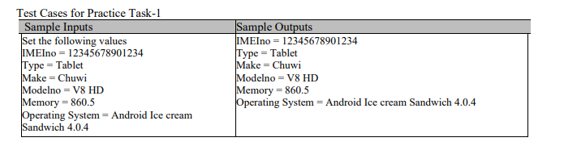
Task2: Write a class called quadrilateral. Your task is to store the length of all the sides of the quadrilateral and the value of the 2 opposite angles within the quadrilateral. Then implement member functions:
1. To compute the area of the quadrilateral.
2. To compute the parameter of the quadrilateral.
3. A constant method that will display the length of all the sides, the angles, the parameter of the quadrilateral and area of the quadrilateral.
4. Create setter and getter methods.
Demonstrate the use of the object in the main function. Make sure that the function names are meaningful and self-descriptive.
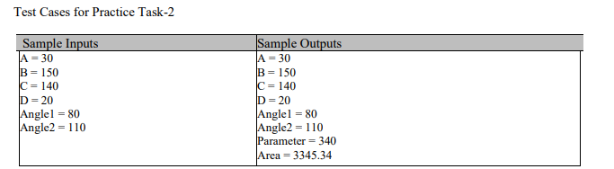

Task 3: Write a C# program for a new ice cream vendor called PopSalon. The management of PopSalon has decided to sell their popcorn in 11 different flavors: chocolate, English toffee, salted caramel, caramel, jalapeño, cheese, spiced cheese, plain salted, buttered, salt and pepper, and garlic. Carefully design the program while adhering to the following rules:
- Pricing Structure: PopSalon charges Rs. 100 for a small pack, Rs. 250 for a medium-sized pack, Rs. 500 for a large-sized pack, and Rs. 750 for a large-sized tin pack. You must implement a function to determine the size of the pack and, based on that, assign the correct price. If a user enters an option number other than the ones displayed, the program should show an invalid input message and prompt the user to re-enter a valid option.
- Gift Wrapping: Customers have the option to purchase a gift wrapper for their popcorn. If the customer chooses to buy a wrapper, an additional Rs. 50 should be added to the total amount payable.
- Additional Toppings: If a customer requests an extra topping, the following additional charges should be applied: Rs. 50 for chocolate sauce, Rs. 30 for caramel sauce, and Rs. 60 for melted cheese. Implement a function that will be called when the customer chooses an additional topping.
- User Interaction and Billing: The program should display a menu that asks the customer for their preferences and then provides a final bill with complete details, including the selected flavor, pack size, and any additional toppings.
- Customer Feedback and Contact Details: For service quality inspection and monthly product promotions, the program should prompt the user to enter their contact details, including name, mobile number, and email address. Additionally, the customer should be asked to rate the quality of service by selecting one of the following options: Good, Neutral, or Bad.
- Destructor and OOP Practices: At the end of the program, implement a class destructor that displays a thank-you message to the user. Ensure that the program follows sound object-oriented programming (OOP) principles. Carefully determine the appropriate data members, member functions, and access specifiers.
Consider the necessary activities to be performed in the constructor. Maintain good naming conventions throughout the code. A well-structured and thoughtfully designed program can earn you higher marks.
Test Case for practice Task-3:
